**SQL QUERIES**

**1. Total Revenue:**

SELECT SUM(total_price)AS Total_Revenue FROM pizza_sales;

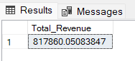

**2. Average Order Value**

SELECT (SUM(total_price)/ COUNT(DISTINCT order_id))AS Avg_order_Value FROM pizza_sales;

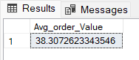

**3. Total Pizzas Sold**

SELECT SUM(quantity)AS Total_sold_pizza FROM pizza_sales;

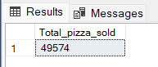

**4. Total Orders**

SELECT COUNT(DISTINCTorder_id)AS Total_Orders FROM pizza_sales;

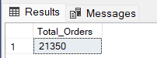

**5. Average Pizzas Per Order**

SELECT CAST(SUM(quantity)ASDECIMAL(10,2))/

CAST(COUNT(DISTINCTorder_id)ASDECIMAL(10,2))

AS Avg_Pizzas_per_order

FROM pizza_sales;

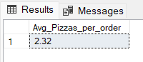

**6.Daily trend for total order Monthly trend for total order**SELECT to_char(order_date,’Day’)AS order_day,COUNT(DISTINCT order_id)AS total_orders

FROM pizza_sales

GROUP BY to_char(order_date,’Day’);

***Output:***

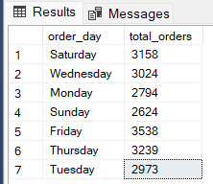

**7.Monthly trend for total order**

Select To_char(order_date,’month’)as Month_Name,COUNT(DISTINCT order_id)as Total_Orders

from pizza_sales

GROUP BY To_char(order_date,’month’);

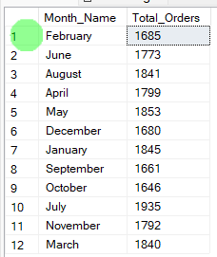

**8. Percentage of sales by Pizza Category**

SELECT pizza_category,CAST(SUM(total_price)AS DECIMAL(10,2))as total_revenue,

CAST(SUM(total_price)* 100 /(SELECT SUM(total_price) from pizza_sales)AS DECIMAL(10,2))AS PCT

FROM pizza_sales

GROUP BY pizza_category;

***Output***

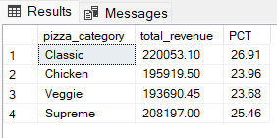

**9. Percentage of sales by Pizza size**

SELECT pizza_size,CAST(SUM(total_price)AS DECIMAL(10,2))as total_revenue,

CAST(SUM(total_price)* 100 /(SELECT SUM(total_price) from pizza_sales)AS DECIMAL(10,2))AS PCT

FROM pizza_sales

GROUP BY pizza_size

ORDER BY pizza_size;

***Output***

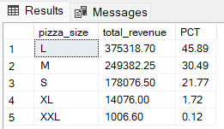

**10. Total Pizzas Sold by Pizza Category**

SELECT pizza_category,SUM(quantity)AS Total_Quantity_Sold

FROM pizza_sales

GROUP BY pizza_category

ORDER BY Total_Quantity_Sold DESC;

***Output***

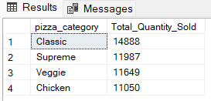

**11. Top 5 Pizzas by Revenue**

SELECT pizza_name,SUM(total_price)AS Total_Revenue

FROM pizza_sales

GROUP BY pizza_name

ORDER BY Total_Revenue DESC limit 5;

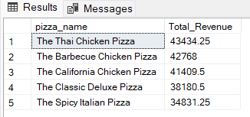

**12. Bottom 5 Pizzas by Revenue**

SELECT pizza_name,SUM(total_price)AS Total_Revenue

FROM pizza_sales

GROUP BY pizza_name

ORDER BY Total_Revenue limit 5;

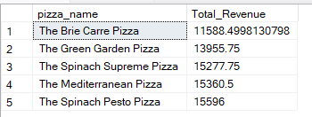

**13. Top 5 Pizzas by Quantity**

SELECT pizza_name,SUM(quantity)AS Total_Pizza_Sold

FROM pizza_sales

GROUP BY pizza_name

ORDER BY Total_Pizza_Sold DESC limit 5;

***Output***

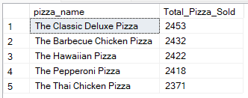

**14. Bottom 5 Pizzas by Quanitity**

SELECT pizza_name,SUM(quantity)AS Total_Pizza_Sold

FROM pizza_sales

GROUPBY pizza_name

ORDERBY Total_Pizza_Sold limit 5;

***Output***

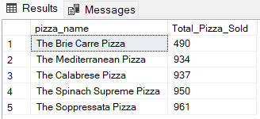

**15. Top 5 Pizzas by Total orders**

SELECT pizza_name,COUNT(DISTINCT order_id)AS Total_Orders

FROM pizza_sales

GROUPBY pizza_name

ORDERBY Total_Orders DESC

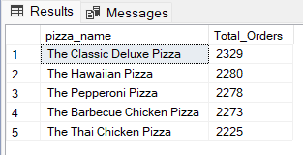

**16. Bottom 5 Pizzas by Total orders**

SELECT pizza_name,COUNT(DISTINCT order_id)AS Total_Orders

FROM pizza_sales

GROUP BY pizza_name

ORDER BY Total_Orders Limit 5;

